Shabbos Stories for
Yom tov pesach 5778
Volume 9, Issue 30 15-22 Nissan 5778/ March 30 – April 7, 2018
Printed L’illuy nishmas Nechama bas R’ Noach, a”h

For a free subscription, please forward your request to keren18@juno.com

The Noda B’Yehudah and the Great Pesach Miracle in Prague



A story once occurred with the Noda B’Yehudah, Rav Yechezkel Landau, who was appointed as Rav of the Jewish community in Prague in 1755. Once he was out walking, and he noticed a small boy, a non-Jew, who was standing on a corner crying bitterly.
The Noda B’Yehudah felt compassion for him, and asked why he was crying. The child responded, “I am an orphan. My mother passed away and my father has gotten remarried to a mean woman who treats me terribly. She wakes me every morning when it’s still dark outside, and gives me a basket full of rolls to sell, and I am not allowed home until I sell all the rolls. Today, I was able to sell all the rolls, but as I was about to go home, I realized that I can’t find the money from selling the rolls, and I am afraid to go home!”
The Noda B’Yehudah inquired, “How much money did you lose?”
The boy told him the amount, and the Noda B’Yehudah whispered to himself the Pasuk from Ashrei, ‘V’Rachamav al Kol Ma’asav’, ‘And Hashem is compassionate on all His creations’ (Tehilim 145:9). He took the exact amount out of his pocket and gave it to the child.
The boy was overjoyed and thanked the nice Rabbi for being so kind to him, and the Noda B’Yehudah said that one day, he should remember that the Rabbi of the town helped him out, and the boy happily went on his way home.
Many years passed, and the Noda B’Yehudah had completely forgotten about this episode. One evening, on Chol Hamoeid Pesach, there was a knock at the door of his house.
The Noda B’Yehudah’s wife opened the door, and saw a young man standing there, a non-Jew, and he said that he wished to speak with the Rabbi privately. She was cautious and wondered what this could be about, but she knew better than to refuse him, and she invited him in.
When the man came before the Noda B’Yehudah, he asked, “Do you remember me?” The Noda B’Yehudah looked hard at the young man, but admitted, “I’m sorry, but I don’t recognize you.”
The young man said, “I am the orphan you helped many years ago. To this day, I remember how you gave me some money, and I’ve come now to return the favor. I need to tell you something very important. The Jews of Prague are about to suffer a great catastrophe.”
The Noda B’Yehudah was apprehensive and he asked what was about to occur. The man continued, “Last night, there was a meeting at my house. It was led by the priest, my stepmother, and all the bakers in Prague. They devised a plan to destroy the Jews. The bakers know that every year, on the day after Pesach, all the Jews buy bread from them. They have schemed to poison every loaf of bread that is baked after Pesach, and kill all the Jews. All the non-Jews know not to eat any bread on the day after the holiday. I am risking my life by telling you this, but I will never forget your kindness to me so many years ago.”
When the Noda B’Yehudah heard this, his face turned white. But he immediately strengthened himself, and told the young man, “I thank you from the bottom of my heart for coming to me and telling me of this terrible threat to the Jews. Your reward from Heaven will be very great, and I will never reveal that it was you who told me of this!”
For a long time, the Noda B’Yehudah tried to think of ways of how he could save the Jews, until he finally came up with a plan. He asked his Gabbai to announce that on the last day of Yom Tov after Shacharis, he would be giving a very important Drashah in the main shul in town, and that everyone— men, women and children— must come to hear him speak.
The Gabbai set out immediately to make the announcement. That morning, on the last day of Pesach, the Shul was completely packed, as everyone was curious to hear what was so urgent.
After Davening, the Noda B’Yehudah stood up to address the crowd still wrapped in his Tallis, and said:
“My friends, unfortunately, as the generations pass, the Torah becomes more and more forgotten to us. The Rabbis become less worthy and mistakes are more frequent. This year, there has been a great mistake in the calendar. The Bais Din of Prague has made an error, and Pesach should have begun one day later than it did. The day we celebrated the first day of Pesach was really Erev Pesach. Baruch Hashem we have caught this mistake, as we have almost brought the entire Jewry of Prague to eat Chometz on Pesach. Therefore, the last day of Pesach will be one day later than we thought, and I forbid everyone to eat Chometz until after Maariv tomorrow evening, since that is really when Pesach is over.”
The Jews listened in astonishment. Many had questions, but no one dared argue with the Noda B’Yehudah. If this was what their Rav decided, then they would follow his decision, and everyone accepted the ruling to extend Pesach one more day.
The next morning, all the bakers came to the Jewish part of town with wagons loaded with warm loaves of bread, as they did every year. They were sure that within a few hours they would sell all their bread to the Jews. However, the day was passing by and they hadn’t sold a single loaf of bread.
One baker asked a Jew that was walking by why no one was buying bread that day, and he responded that their Rabbi said that Pesach was extended and they couldn’t eat bread yet. The bakers were furious at this and they went to tell the priest what had happened.
The priest was quite angry and summoned for the Noda B’Yehudah to appear before him immediately. When he arrived, all the bakers were gathered there, along with the chief of police, and the priest accused the Noda B’Yehudah of trying to ruin the business of the bakers. He said by telling the Jewish people to not buy bread, it prevented the bakers from making a living, and he demanded that the Noda B’Yehudah explain himself.
Calmly, the Noda B’Yehudah said, “Your Excellency, I am happy to answer you, but first, I request that a dog be brought in to this assembly.” The priest was caught off guard by this request, but agreed to it, and a dog was brought in before them. The Noda B’Yehudah said, “I have reason to believe that the bakers are not so much interested in their livelihood, but are looking to harm the large Jewish community. I would like to examine this bread to see that it is fit to be sold.”
When the bakers heard this, they became very uneasy and frightened, but the police chief allowed the Noda B’Yehudah to continue. The Noda B’Yehudah took one of the loaves of bread from one of the wagons and fed it to the dog. Within a few moments, the dog began to look disoriented, barked, and fell dead to the ground. It was clear that the loaves of bread had been poisoned.
The Noda B’Yehudah said, “This is the bread that was attempted to be sold to the Jewish people.” The police chief immediately ordered the bakers arrested, and under questioning, they revealed that the plot was led by the priest, and all of them were punished.
When the Jews learned what had happened and how they had been saved, they praised the Noda B’Yehudah’s brilliance. The Noda B’Yehudah publicly declared what a great miracle Hashem had performed for His people, and he thanked Hashem for beginning the salvation so many years ago, by giving him the desire to help the non-Jewish orphan, whose identity he kept secret for his entire life.
Before he passed away, the Noda B’Yehudah recounted this story to his son, Rav Shmuel Landau, and he told him, “I want you to know that it was not through any special wisdom that I was able to come up with the plan to save the Jews, but it was because of a kindness that I once did for a young gentile child!”

Reprinted from the Parshas Emor 5777 email of Torah U’Tefilah: A Collection of Inspiring Insights compiled by Rabbi Yehuda Winzelberg.

Rabbi Pincus Tells How He Merited to Come Close to G-d
By Naamah Green

If there's anything in me today it's all from one rabbinic commandment, checking for Chametz, (leavening) which I did to the highest degree with self-sacrifice

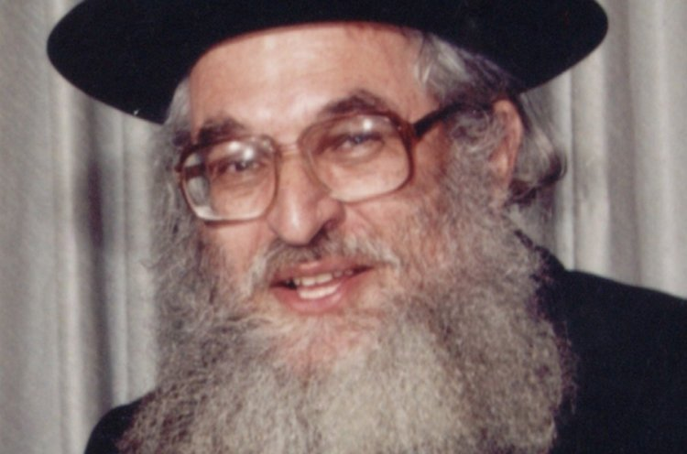
Rabbi Shimshon Dovid Pincus, zt”l

Rabbi Shimshon Pincus of blessed memory passed away 15 years ago and he was well-known for the love of God that burned in his heart. This fire characterized all his speeches in which he would kindle the hearts of Jews to learn Torah and serve G-d. This love burned even brighter every time he would do any mitzvah whether between man and man or between man and G-d. If he accepted something upon himself he went all the way with it and didn't spare any effort to fulfill it properly.
For many years people wanted to learn the secret how he merited the great heights that he reached in serving G-d? Where did he start from and how did a young American boy grow up to be an elevated person with real closeness to G-d?
Rabbi Pincus in his humility would never talk about himself and evaded the question. In a rare moment he explained the following to his family and friends. He actually wrote this story in an introduction to his Haggadah of Passover Tiferet Shimshon.
When I was a student in the Brisk Yeshiva I lived in an apartment with a few roommates. Since I was from out of Israel and I did not return home for Passover the situation was that I had to check my own apartment by myself and I was responsible for the whole apartment.
The apartment was big, old and neglected so checking it for Chametz went late into the night. I worked for room to room it took great effort moving obstacles preventing me from checking. There were many other things that made the checking difficult. Finally I finished checking the apartment close to midnight. I collapsed on the chair feeling worn-out but full of satisfaction.
Just then another thought disturbed my rest. I remembered that there's a joint attic that belongs to the whole building and in reality everyone was responsible to check it. But I knew that if I don't check it now, no one else is going to do it.
Inside my heart a battle was raging. On one hand I was worn out and tired and I knew that I did above and beyond my obligation. On the other hand I knew that these thoughts were based on physical tiredness and really the best thing for me to do would be to go up and check the attic.
After a few minutes of internal debate I decided I'm not giving in. I decided to do the Mitzvah totally in the most complete manner with self-sacrifice. I climbed up with the last of my strength into the attic. When I open the old door and turned on the light I was shocked by what I saw. It was obvious that no one cleaned here for years if at all! The floor was covered with a thick layer of dust and in every corner there were items strewn around.
The rabbi continued and repeated a law that he remembered when he saw the attic; “Every man has to clean up his room before checking.” That means even before the tedious job of checking he would have the task of cleaning it up.
The tiredness that overcame all my bones almost made me give up but I remembered then that I made up my mind to do this Mitzvah with self-sacrifice no matter what. So I made believe I didn't just finish a few hours of work in my own apartment. I grabbed buckets of water and I started working.

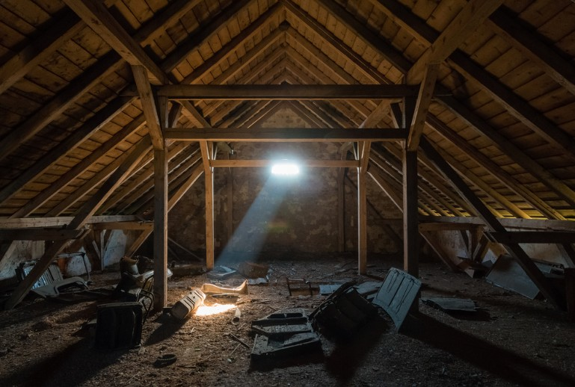

A stranger coming up to the attic at that time would have been shocked by what he saw; a young American student covered with mud and plaster cleaning a place that was almost never cleaned and probably almost no man ever set foot there. All this is taking place way after midnight the night before Passover.
It was close to dawn when I finished checking the entire attic for Chametz. My whole body was shaking from the effort and the great tiredness that came over me. When I finished, it was already sunrise. In the morning after praying I hoped to rest a bit but the Mitzvoth of the day like burning the Chametz made me forgo my rest even though I was really tired.
Right before the evening prayers on the Seder night I thought to myself sadly: “What kind of Seder can I hope for if I am so wiped out? My tiredness will overcome me! Who knows if I'll be able to drink the four cups of wine at all?” I started praying with mixed feelings but as soon as I started praying I forgot everything. A spirit of holiness came to lift me up and a sweet feeling that I never felt before rested upon me.
I began my Seder night with those elevated feelings and to my wonderment I didn't feel tired at all. Quite the opposite I was so alert that I did not want to waste even one moment of the holy night. I read the Haggadah with an elevated spirit and my heart was overflowing with happiness. The words of the Haggadah weresweet on my lips.
I fulfilled all the mitzvoth of the night such as eating matzo, bitter herb and drinking 4 cups of wine feeling elated. I wasn't tired at all and I felt with my whole being that I am prepared to sacrifice myself to keep the mitzvoth.
I became a different person. I felt true closeness to G-d and a great light enveloped me the whole Seder night until after midnight. To my great wonder, even after the Seder was completed, I couldn't fall asleep. I stayed up the whole night and went over the story of leaving Egypt until the morning. I was surprised to find that this elevated spirit acompanied me from the Seder night till the end of the holiday. I took advantage of the opportunity to expend great effort in prayer and Torah learning. You can say that on that Passover, I dealt with nothing but closeness to G-d.
In that year, the seventh day of Passover was a Friday and during the last afternoon prayer of Passover, tears came to my eyes. I feared very much that the spirit of holiness that rested upon me all of Passover would weaken and leave me when the Sabbath came. I strengthened myself with the thought that Shabbat is even holier than the holiday. I decided to keep on striving to go higher spiritually. I hoped for continued assistance from on high. Indeed I felt for the first time the very sweet taste of the Holy Shabbat and for the first time I understood the essence of its holiness. From that moment on I started rising to higher levels in my Divine service.
Rabbi Shimshon concludes his secret saying: If there's anything in me today, it all came from that one rabbinical Mitzvah; the Mitzvah of checking for Chametz that I grabbed onto and fulfilled with self-sacrifice.

Reprinted from the Pesach 5777 email of Hidabroot.

Describe a Person Properly
By Rabbi Sholom D. Avtzon



Since this upcoming Wednesday is Chof-Beis (the 22nd) of Shevat, the Yahrzeit of Rebbetzin Chaya Mushka, I chose to relate the following vignette/snippet of her life, with the hope that we will learn from it. As the Rebbe continuously said after her petirah, Vihachai yieten el libo - and the living shall take to heart.
Reb Berel Raskin sheyichye, would supply fish for the Rebbe’s house. One year on Erev Pesach, he began enumerating to the Rebbetzin the hiddurim he did and how he scrupulously prepared their fish for Pesach.
(He mentioned to me two of the hiddurim that he was careful with, which he thought the Rebbe would want.) Instead of packing the fish in plastic bags, he placed them in glass jars as well as using a special set of knives and utensils exclusively for their fish order.
The Rebbetzin thanked him and said, “Mr. Raskin, zei nisht azoi nerveiz, mein mahn fahrluzt zich oif dir – Mr. Raskin, don’t be so nervous, my husband trusts you. [i.e., You don’t have to prove it, by specifying everything you did].”
She then said, “It is a proper thing that you cleaned the store and machinery for Pesach. I heard that other storekeepers say, ‘My store is Kosher L’Pesach year round and there is no need to clean it before Pesach.’ That is not how we were raised. I remember as a youngster, how my grandfather [the Rebbe Rashab], my father [the Frierdiker Rebbe], and everyone in the house, would take out the wooden boards to the courtyard and we scrubbed and scoured it, so that it should be cleaned for Pesach, even boards that definitely had no contact with Chometz throughout the year.”

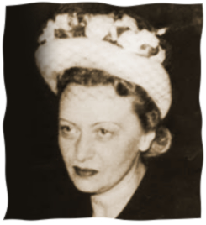
Rebbetzin Chaya Mushka, a”h

The Rebbetzin then said, “If you have a few moments I will mention another difference between then and now.
When I was growing up in Lubavitch, the way a person was described as was, “Der yid, di vasser truger – the Jew who brings water from the well, der yid di shneider – the Jew the tailor, der Yid di katzov – the Jew who is a butcher, etc.
“But here in America, they are called by their profession or livelihood, one is called the baker, another one is the butcher, grocer, tailor or taxi driver.”
Compiler’s note: I believe she was saying that the proper approach is to recognize that his essence is that he is a fellow Jew, whose source of livelihood may be one thing or another, but that is not his essence. His essence is Der Yid.
Rabbi Avtzon is a veteran mechanech and the author of numerous books on the Rebbeim [of Lubavitch] and their chassidim. He is available to farbreng in your community and can be contacted at avtzonbooks@gmail.com

Reprinted from the February 1, 2018 Weekly Story email of Rabbi Avtzon.
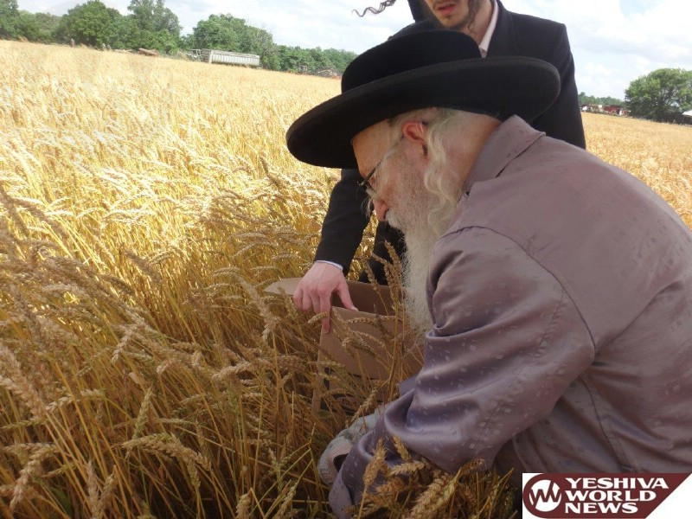


Serdaheli Rov Supervising the cutting of wheat for matzos (Photos by JDN)
Reprinted from the June 21, 2017 website of Yeshiva World News.
Chareidi Family Fined
For Singing Too Loudly
At Their Pesach Seder

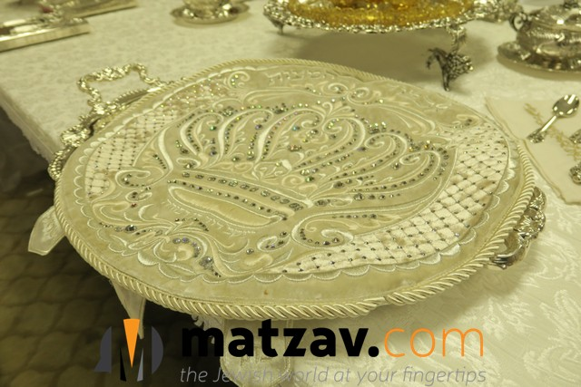

A Bnei Brak family was fined $95 on Pesach after neighbors complained about their singing.
“We held the seder the same as every Jewish home,” Rav Chaim Shaul Rosenberg told Chadrei Chareidim. “My neighbor, a religious Jew, was apparently bothered by our singing and cut off our electricity via the lobby power box. We still had light from the candles in the living room and from an adjacent room and continued the yom tov meal. But a few minutes later, police arrived and demanded that we stop the noise. I told the police officer, ‘We have already begun the meal and will try to finish soon and be quiet.'”
Police returned soon afterwards and fined the family $95.
MK Yisroel Eichler of UTJ wrote to Environmental Minister Ze’ev Elkin and demanded an immediate cancellation of the fine. He noted that it was just as well that Israeli police officers were not around when Rabi Akiva and the chachomim celebrated a seder all night in Bnei Brak or they too would have been fined.

Reprinted from the May 3, 2017 website of Matzav.com
The Special Cup of Elijah
By Rabbi Tuvia Bolton

Once there was a very rich Jew who we will call Yitzchak, who was a follower of the great Tzadik and holy genius Rebbe Yisroel of Ruzhin. Yitzchak was known for his warm heart and open hand. He gave a lot of charity. Every day his home was filled with the poor and hungry coming for a handout, a meal or just a place to rest for a while. But where he really shined was on Pesach (Passover).


Partial view of the palace of the Ruzhiner Rebbe in Sadigura.

Every year more than a hundred guests graced his table. People came from far and wide to partake of the joyous celebration of remembering the miracles G-d did thousands of years ago and hoping for even greater ones.
But, as we all know, there is a wheel of fortune in the world and so it was for our hero. It’s not important how but suddenly Yitzchak's fortune dwindled until within months he lost everything and found himself a pauper with almost nothing to eat.
In order to pay his creditors, he was forced to sell his businesses, his properties and even his furniture. His wife sold her jewelry and everything of value in the house including their precious candle sticks until his house was a virtual shell¦ and it would only be a matter of time till it would have to be sold as well.
But there was one thing that his wife refused to part with. She had sold all her fine dresses and ornaments, even her family heirlooms but she refused to part with the Kos Shel Eliahu; the cup we fill with wine for Elijah the Prophet (who was taken in a wind to heaven some 2,800 years ago and supposedly visits every Passover Seder) at the end of the Passover Seder.
It really made no sense. The cup was made of gold and would surely have brought a good sum. Every so often her husband would add a jewel or golden inscription to it so it was worth a lot of money. But she refused to let it go. "It's our only hope." She said. "Elijah will announce Moshiach and Moshiach is our only hope."
Yitzchak was in no mood to argue with her. If poverty didn't convince her to sell it he surely wouldn't. And deep down he knew, or at least hoped, that she was right.
But the morning before the Pesach Seder their house was barren. Somehow they scraped together enough money for a bottle of wine, a few Matzot, some potatoes and a small piece of fish. But beside that and a small table, two chairs. and their cup for Elisha, they had nothing.
So with only hope (which was waning) and an empty stomach (which was waxing) he told his wife he was going to the synagogue that morning and would return only that evening for what was sure to be a lonely, quiet, shadow-of-the-past Seder.
He sat alone in the Shul (Synagogue) and did his best not to weep. But it wasn't easy. The thought of days gone by and of the dismal future; maybe next week he wouldn't even have his house, haunted him.
Close to evening he went to the Mikva, washed up, immersed himself, changed his clothes and tried to keep a smile on his face and a song on his lips as returned to the Shul, prayed with the congregation and slowly walked home alone.
But as he approached and saw his house in the distance his forced smile faded and he fell silent in awe. His house was.. ablaze with light! From inside¦ it was filled with people!
He thought that perhaps he had lost his mind. He shook his head as though trying to wake up. He rubbed his eyes and held his temples in disbelief and approached.
He opened the door and it was like a dream. His huge front room was filled with guests, maybe a hundred of them, all joyously, handsomely dressed and busy arranging their places at a huge, long, decorated table. Lights and candles were shining everywhere! He looked at his wife. She was dressed like a queen! She gazed back at him, her eyes sparkling with sweet tears of joy as she raised her arms and announced,
"My husband! Rav Yitzchak!!"
Everyone stood and applauded and poor Yitzchak broke down in tears and swooned. He would have fallen on his knees and raised his hands in thanks to G-d but it just didn't seem to be the right thing to do so he wiped his eyes, held up his hands for silence and yelled, "Good Yom Tov (holiday) everyone!! Thank G-d for everything!!" and everyone answered "Good Yom Tov!!" and resumed finding and arranging their places.
His wife approached, smiling from ear to ear, and explained.
"Just after you left this morning, a carriage pulled up in front of the house and an important looking Jew got out and knocked at our door. He said that many years ago he had been at our Passover Seder and never forgot it. He said that his carriage happened to break down here yesterday and he just got it fixed. He wanted to know if it was all right if he spent the Passover with us again.
“But when I told him that we didn't have enough food for guests he insisted that money was no problem and he gave me five thousand guilder! Five thousand!!
“"I tried to refuse. I told him it was a thousand times what we needed. But he insisted. In fact, he even took the money back and gave it to his servants to buy food and hire workers to prepare it. He even bought new furniture and tapestries! It's unbelievable! In just hours the food and pots and everything were delivered, the stove was burning, the house was busy and people were coming from all over to help. It's a miracle! And soon he'll be here. He told me not to wait for him, that he would be a bit late but I'm sure he'll be here any moment and we can thank him."
That Seder night was probably the best and happiest that Yitzchak and his wife ever had in their lives and, sure enough, when the meal was almost finished, their rich benefactor appeared, apologized for being late, hurriedly found a seat, and before anyone knew it finished his Seder quickly and quietly and approached them.
They thanked him profusely to which he replied. "I understand that you've been having a hard time financially. Well, I bless you with greater riches than before." And with those words, he turned on his heels and left.
Sure enough, several of the guests that night were businessmen and as soon as the holiday ended, eight days later, Yitzchak was back in business and in just a few weeks he was making money and giving charity like never before.
Months later Yitzchak visited his Rebbe, told him the entire story and gave a him a huge donation. The Rebbe put his head down for a minute, lifted it and said.
"That rich man was Elijah the Prophet. You merited seeing him once and your wife merited to see him twice! It was all in the merit of that cup and her simple faith. She was right! Your only hope was Elijah."

Reprinted from the Parshas Shemini 5777 email of Yeshiva Ohr Tmimim in Kfar Chabad, Israel. Adapted from Sichot HaShavua #1162.

Don’t Make Passover
Too Easy
By Jeffrey Yoskowitz

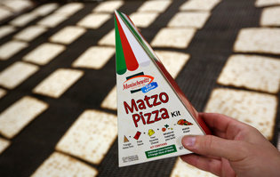
Manischewitz unveiled triangular matzo this year.CreditSeth Wenig/Associated Press

Eleven years ago, I stayed with a Jewish family in Zimbabwe for Passover. There was no supermarket with kosher holiday foods nearby, so nearly every dish was made from scratch, from the chopped herring down to the stuffed grape leaves. My hosts had roots in both Lithuania and the Greek island of Rhodes, and each dish was rooted in the family’s distinct story; a few even featured the avocados growing in the backyard.
I spent the next Passover back in the United States. For the seders, I enjoyed some of my family classics, like potato kugel, brisket and matzo ball soup. I spent the rest of that holiday, however, eating a considerable amount of packaged “kosher for Passover” foods, such as matzo and jam, special cereal and other snacks. I longed for my meals in Zimbabwe — though I don’t doubt that my hosts would have appreciated access to the kosher aisle of an American supermarket to ease the burden of navigating the very elaborate and specific eating guidelines of Passover.
For a holiday all about freedom, Passover dietary restrictions — no bread or leavened goods and, traditionally, for Ashkenazi Jews, no legumes, rice or corn — can be quite taxing. Despite this complex set of rules and customs, a growing number of processed foods that meet these age-old Passover restrictions can now be found in supermarkets across this country. It’s increasingly possible to eat the same way on Passover as on any other day of the year, perhaps with a larger dose of tapioca and potato starch.
Yet embracing the holiday’s tedious dietary restrictions, not working around them, is critical to appreciating this holiday on a deeper level. And to eating well.
Generations ago, Passover preparations did not start at the supermarket. Jews in Baghdad spent months making wine and date syrup, pickling vegetables and baking matzos. Ashkenazi Jews in Eastern Europe rendered goose and chicken fat and set it aside in early winter.
In the United States, mass-produced items began replacing homemade Jewish dishes in the middle of the 20th century (think gefilte fish from a jar, latkes and matzo balls from a box). Today the kosher offerings in supermarkets include a wide array of Passover products, from frozen gluten-free pizzas to cakes, sriracha mayonnaise and ice cream cones.
The number of unique Passover food items has more than doubled since 2011, to 52,000 from 23,000, according to Menachem Lubinsky, editor in chief of the trade newspaper Kosher Today. The holiday is the cornerstone of a multibillion-dollar industry. While corporate giants like Coca-Cola make Passover versions of their products, most are produced by specifically Jewish brands, according to Roger Horowitz, author of “Kosher USA.” About 40 percent of sales in the kosher food market are for Passover alone.
In so many ways, mass-produced kosher foods have made the holiday far less onerous. Families that once kept live fish in their bathtubs the week leading up to the holiday to make fresh gefilte fish no longer needed to turn bathrooms into aquariums. But what have we lost?
What defined Passover cooking around the world were the flavors of springtime, the ingenious substitutions for basic ingredients developed by clever cooks and the reliance on pure, simple ingredients. In northern climates, there isn’t a bounty of produce in early spring, so Jews relied on pickled foods they stored through winter, and foraged for wild spring greens, mushrooms and roots like wild horseradish. Sorrel soup, known as schav, is a traditional Eastern European Passover specialty.
Jewish cooks got creative. My grandmother made pancakes and “bread” rolls out of crushed matzo meal, which seemed like alchemy to me as a child. My great-aunt Yetta added a touch of potato starch to eggs, which she’d fry into a thin crepe, then either shred it into “noodles” or wrap it around farmers cheese for blintzes.
Dessert is a real miracle of Passover. Meringues, macaroons and chocolate are so prevalent on Passover because of the simplicity of their ingredients. The chef Yotam Ottolenghi writes that unleavened cakes are the “mother of great invention.” Ground nuts replaced flour; citrus sugar syrup or amaretto prevented it all from drying out.
In many ways, how we eat for the week of Passover is a reflection of ourselves, and it’s no surprise that the Passover table looks more like a typical American table. The fact that an entire aisle is dedicated to mass-produced Passover foods in many supermarkets signals the ways in which the Jewish community has been accepted into American life.
But that acceptance can be precarious. The challenge of making a meal with so many restrictions serves as a reminder of where Jews have come from and the importance of retelling the story of a time when they were not so fortunate.
This Passover, I suggest leaning into the limitations, rather than working your way around them. Embrace a restricted pantry and track down old recipes to make unique Jewish holiday dishes like matzo brei and dried fruit compote. Head to the farmers market to get a taste of the early spring greens and foraged foods.
As you grate potatoes for your kugel or chop walnuts for haroseth, remember that these foods tell the story of an identity in formation. And as you shape your matzo balls, reflect on the years of struggle for the privilege to be able to buy Passover pasta and matzo granola in a mainstream American supermarket.

Jeffrey Yoskowitz is a co-author of “The Gefilte Manifesto: New Recipes for Old World Jewish Foods” and co-owner of the Gefilteria, a purveyor of Ashkenazi cuisine.

Reprinted from the April 8, 2017 website of The New York Times. A version of this op-ed appears in print on April 9, 2017, on Page SR5 of the New York edition with the headline: Skip the Passover Pizza.

No Greater, No Lesser
Defying the Soviet Regime to Defend Jewish Integrity in Baking Matzas

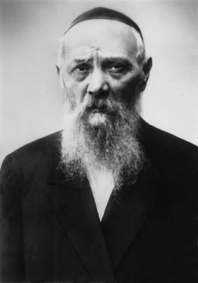

"Moses, our teacher, is very, very great. But he is no greater than a Jew. At the same time, the simplest Jew is very simple, but he is no lesser than a Jew."
This was a favorite saying of Rabbi Levi Yitzchak Schneerson, Jewish leader, scholar, Kabalist, and father of the Rebbe, whose anniversary of passing occurs this week.
As certain as Rabbi Levi Yitzchak was that every Jew is equal in G-d's eyes, that is how fearless he was in defending every Jew and the Torah's laws in the face of government or other intimidation.
To illustrate: It was in the early years of the Soviet regime, when all commerce and business throughout the country had already been nationalized.
All of the mills and matza bakeries were run by the government. When it was time to ship the wheat for the matza and they needed a certifying rabbi, the government asked Rabbi Levi Yitzchak as they had in previous years.
However, that year, the government representatives explained that if any of flour would not be allowed because it did not meet his approval, there would be a monetary loss to the government and it would be interpreted as a declaration of war against the state.
Rabbi Levi Yitzchak was unbending. If they allowed him to hire people whose instructions would be strictly obeyed, he would certify the flour. And if not, he would not comply. And not only that, he would make sure to publicize that it was not under his supervision.
The government representatives threatened Rabbi Levi Yitzchak who declared that he was ready to travel to Moscow and meet with the president of the Soviet Union to discuss the matter. But he absolutely refused to put his name on something that did not deserve it, as it was against Jewish law and against G-d.
The matter was referred to the highest authorities. In the end, the government representatives were told that everything Rabbi Levi Yitzchak said must be followed to the letter.
And that is what happened that year, and the next year and the next. In all of the government-sponsored matza bakeries throughout the Soviet Union, only the flour approved by Rabbi Levi Yitzchak was used.
In retelling this story about his father, the Rebbe [Rabbi Menachem Mendel Schneerson, zt”l] shared the life-lesson that can be gained from it. "When a Jew stands firm and declares that he cannot act contrary to G-d's command, nor is he willing to do anything against Jewish law, he will ultimately succeed.
"Of course, not everyone can demonstrate such strength. But it is also true that not everyone must oppose an entire government ruling over 200 million people. All that most of us need to do is to take a stand against our own evil inclination."
May we all have the strength to take a stand wherever and whenever we need to!

Reprinted from the Parshat Va’eschanan 5776 edition of “L’Chaim Weekly” published by the Lubavitch Youth Organization of Brooklyn, NY.

Story #960

A Passover Seder Debate
From the desk of Yerachmiel Tilles
editor@ascentofsafed.com

It was the day before Passover 5516 (1756), and as on all Jewish holidays, many of the followers of the holy Baal Shem Tov came to Mezibush to spend Passover with their Rebbe. It was always an uplifting, almost magical experience to be in the presence of the Baal Shem Tov, especially at the time of a Jewish holiday. But, on this Passover, the chasidim were upset because they could sense that something was seriously bothering the Besht (Baal Shem Tov). He was not in his usual buoyant spirits.
After the search for chametz on the night before the Seder, the Baal Shem Tov told ten of his closest disciples to say Tikun Chatzot (the midnight prayer to commemorate the destruction of the Temple) with great concentration. While saying this prayer, Reb Tzvi (the scribe of the Besht) came running and yelled, "Lord of the Universe, the Rebbe fainted and fell onto the floor of his study." Everyone was upset, but no one would dare go into the study and disturb the Besht.
The next morning before the Passover Seder, the Baal Shem Tov prayed the morning prayers in what seemed to them a despondent mood. When he finished his prayers, he expounded about 'Trust in G-d': "True and complete faith in G-d can only occur when a person can't see any way to overcome his problem. When, at that very moment, the person believes without a doubt that G-d will save him from his problem, and most importantly, the person shows this trust and faith in G-d by being b'simcha (having a joyful attitude), this joy itself indicates that the person has no doubt that he will soon, with G-d's help, overcome his problem."
As soon as the Besht finished this discourse, his mood noticeably changed. He seemed more at ease. The followers whispered among themselves, "The change in the Rebbe's mood is not because of a change in the spiritual decree about which he is no doubt concerned. No," everyone agreed, "the change in the Rebbe will change the Heavenly decree, G-d help us."
In the afternoon of that same day, when the time came to bake the matzos (matzos made after midday before the Seder are considered the most precious), the Baal Shem Tov immersed in themikveh (ritual pool) before coming to the bakery. His mood had improved even more and he actually seemed to be happy.
That night, in the synagogue of the Baal Shem Tov, the special evening prayers for Passover were chanted with great enthusiasm. After the prayers, his close disciples who were invited to theSeder of the Besht sat around the Seder table eagerly awaiting to hear his insights on the Haggadah. But this Passover night was different because the Besht did not expound on the deep mystical meanings of the Haggadah. Instead, to the disappointment of his guests, he just quietly read the text.
Near the end of the Seder, the Baal Shem Tov closed his eyes. The disciples looked at each other, "Is he in a state of deep meditation or did he 'almost' fall asleep." The room was silent. Suddenly, the Besht started laughing so hard that he could barely sit still in his chair.
"Mazel Tov!" he exclaimed, "Thanks to G-d who has chosen the Torah, Moses our teacher and Israel. You should know that even the simplest Jew can change a Heavenly edict."
The disciples sat speechless as he began to explain.
"Yesterday morning, a terrible edict was decreed in Heaven against the Jews of a nearby village. The non-Jewish peasants in that village were planning to attack the Jews on the first night of Passover.
"I prayed with all my strength, and I even had you help me. But we couldn't overcome the Heavenly decree. I finally gave up and put my trust in G-d that the decree would be rescinded. Right then I started to feel joyful.
"When we sat down to the Seder, the hour for the execution of the decree had arrived. I didn't see any hope for those Jews living in that village. But in a single instant, thank G-d, everything changed.
"During this time, a childless couple among my followers living in the village where the decree was to be executed was sitting at their Seder Table. Although they are simple, unlearned Jews, they are exceptionally kind, devout and full of good deeds. When they reached the section of the Haggadah about the Egyptians throwing the new born baby boys into the Nile, the wife started to cry. Her husband tried to comfort her, 'My dear wife, don't be sad, after all the Jewish people were finally taken out of Egypt.'
"The wife spoke back, 'If G-d had blessed me with a son, I would have protected him and not let anyone hurt him. And I certainly would not have let anyone treat my son the way G-d let us be treated by the Egyptians.'
"The husband defended G-d saying, 'The L-rd is righteous in all that He does, it's only that we can't always see or understand why it is good for us.'
"But the wife answered back, 'Why isn't G-d more compassionate? How could He have treated us like that? Even if we do sin, we are still His children.'
"And so the argument went back and forth as they worked their way through the Haggadah. Meanwhile, the case against the Jews of their village was being argued before the Heavenly Court. The defending angels were more persuasive when the wife presented her arguments and the accusing angels were more persuasive when the husband presented his rebuttals. I really couldn't tell what the outcome would be.
"Finally, after completing the fourth cup of wine near the end of the Seder, the husband couldn't think of another answer to his wife's arguments against G-d's behavior. So he conceded, 'My wife, you're right. G-d should have treated his children better.'
"They started to laugh, got up and began to dance around the Seder table. And at that very moment, the decree in Heaven against the Jews of their village was annulled," the Besht concluded.
The disciples were mesmerized with the story. Then, the Besht told them to place their hands on the shoulders of the person sitting on either side. When the Baal Shem Tov completed the circle by placing his hands on the shoulders of the person sitting on either side of him, the disciples all saw a vision of the husband and wife dancing together around their Seder table celebrating the liberation of the Jewish people from Egypt.
The Baal Shem Tov said with a little chuckle, "They should only know that they are also celebrating the liberation of the Jewish people of their own village."

Source: Adapted by Yerachmiel Tilles from the redition of Tzvi-Meir HaCohen (Howard M. Cohn, Patent Attorney) of a story in Seeker of Slumbering Souls: Stories of the Baal Shem Tov, Volume 1 (Chai Books).
Biographical note: Rabbi Yisrael ben Eliezer (18 Elul 1698-6 Sivan 1760), the Baal Shem Tov ["master of the good Name"], a unique and seminal figure in Jewish history, revealed the Chassidic movement and his own identity as an exceptionally holy person, on his 36th birthday, 18 Elul 1734. He wrote no books, although many claim to contain his teachings. One available in English is the excellent annotated translation of Tzava'at Harivash, published by Kehos.
Passover Overreaction
By Emuna Braverman



If I spend the preparation time yelling at my children, am I really getting rid of the chametz?

One of my children (who shall remain nameless but knows perfectly well who she is!) upended a large tray of cookies onto the living room couch the other night. “Pesach is coming!” I shrieked.
“But the room isn't yet cleaned for chametz,” she pleaded. “What's the big deal?”
I polled my friends. Did I overreact?
“I would have been over the edge if it happened in October,” said one. “Definitely nervous breakdown material,” nodded another.
I calmed down but erupted again when the same child (I hope you're reading this!) sat eating crackers (very crumbly ones I might add) in the aforementioned living room.
And yet I know it's irrational. The house will get cleaned -- even if I have to do it myself! (Oh yeah, I do! No wonder I'm frustrated…) The crumbs will be swept or brushed or vacuumed away. We will, please God, sit down to a delicious meal on Passover night in a chametz-free environment.
The only question is: What state I will be in when we get there (and along the way)?
The real couch is our character; the real crumbs, our negative traits.
If I spend the preparation time yelling at my children, am I really getting rid of the chametz? We are taught that the chametz/leaven symbolizes ego. The real clean-up is a spiritual one. The real couch is our character; the real crumbs, our negative traits.
If I am on edge and testy with everyone as we get ready for the holiday, then I've missed the point. If our home is physically clean but spiritually a mess, then my preparations are incomplete. If I don't sit down to the Seder with a smile on my (tired) face, then my home is still full ofchametz.
So I'm regrouping. I'm taking a deep breath. I'm taking many deep breaths (I'm hyperventilating!) I'm focusing on the atmosphere I want to create and the person I'd like to be.
I may still get frustrated (who put the Cheerios in my eyeglass case?!). I may be a little tense (What cabinet did that cup come out of?), but I'm trying to be better. I'm really trying to get rid of my chametz. I haven't succeeded yet but I'm asking the A-mighty for help. Maybe this is the year I will truly become free.

Reprinted from Aish.com Originally published on March 21, 2010.

A Pesach Miracle in Alsace
By Rabbi Tuvia Bolton

The year was 1848. The spirit of revolution in Europe brought confusion and disorder everywhere and the thin distinction between freedom fighters and bandits dissolved. Gangs of armed hoodlums, hungry for blood and loot were on highways everywhere robbing and pillaging and the ones that especially suffered were who else? - the Jews.
They were rarely armed, were never protected by the police or army and were considered by all the warring sides as siding with the enemy.
Passover was approaching but in the Jewish quarter in the area of Alsace there was fear and weeping.
It seems that a caravan of Jewish wagons, on their way there to spend the Holiday at home with their families had been robbed by an army of two hundred bandits who first stole all their belongings and were about to kill them all until they discovered the wine.
It seems that as well as money their wagons were laden with all the necessities of Passover: presents for the family, food and matzoth for the festive meal and, most important, fifty barrels of fine wine for the ceremonial cups of redemption.
When the bandits realized what a treasure they had stumbled upon they went berserk and immediately began fulfilling their life's goal; getting drunk! And as soon as the wine started taking effect they decided to have some fun, untied their prisoners and scoffing out loud told them to run home saying,
"In any case we're going to take over your entire miserable town tomorrow and you don't stand a chance. So go kiss your families good bye!! Ha Ha Haaaa!!"
So when the Jews made it to their homes the next morning and told everyone what had happened there was mourning and wailing. Passover would begin in nine hours, Jews would be celebrating the Holiday of Freedom all over the world - but not them. Their lives were in danger!
The first instinct was to runâ€¦ but where? The bandits were sure to catch them. Maybe they could pay them off; somehow appease them? But that was also out of the question, their intention was to steal everything. Indeed, the Rabbi pointed out that trying to appease them would only show weakness.
They decided that the only chance they had was to fight.
The richest man in the community, a born leader by the name of Shmuel Leib took command.
"Listen, everyone run home, hide your valuables, arm yourselves with anything that can be used as a weapon and come to my house with your families. If we're together we have a chance! Bring knives, meat cleavers, anything metal. My house is the second one after the gate and they have to pass it to get into the town. We'll put the women and children in the basement and give them a fight they'll never forget."
"What about the first house? The house of Aaron the butcher?" Someone asked.
"I'm sure that my house will attract them." Shmuel answered. "His is first, but it's small and what they are after is money. When they see no one is there they will pass it up. Here is where they will attack first. I'm sure of it! And here we'll surprise them. The butcher and his family will come to my house with everyone else.”
In no time all the men ran home and just hours before nightfall they were all gathered in Shmuel's mansion making plans and preparing their makeshift weapons. They even sent out a few boys dressed in dark clothes to spy on the enemy and report back.
The sun set and the eerie full moon made the dark empty streets glow ominously. The air in Shmuel's house was tense with fear. Their kitchen knives were no match against swords and battle axes. They sat in darkness and waited. As soon as the enemy came near they would attack from all the doors of the house and hope for a miracle.
Suddenly they heard a pre-arranged knock on the door and opened up; it was the boys out of breath.
"They're coming! They're almost at the gate. But Aaron the butcher, he's in his home - he said he’s not coming here!"
"What do you mean?" Shmuel whispered as loud as possible "He isn't coming?! What's he doing at home? Has he gone crazy!? He doesn't stand a chance!"
"He said that tonight is Pesach" the boy answered. "He said it's the night when G-d protects us and that he's not afraid. So he's going to make the Passover 'Seder' and trust in HaShem!"
Someone in Shmuel's house lifted up a window shade and sure enoughâ€¦ there was Aaron the butcher's house lit up as bright as a torch.
"They're coming!" Another of the boys entered and whispered almost hysterically.
The band of thieves silently entered the gate of the Jewish quarter like a pack of human wolves with their weapons in hand and headed toward the lights coming from Aaron's home, overjoyed that the Jews seemingly weren't even expecting them!
Their leader told them to wait and signaled two of his men to accompany him to the back of the house where he told them to lift him so he could see if it was a trap.
Two of his men lifted him and he peaked into the window.
He was shocked! It was the butcher! He recognized him! The butcher bought a cow from him once. But now he looked like a king! And his wife like a queen! And the children like little angels! The entire house was brightly lit and the family was sitting around a festive table with silver vessels on it glistening in the light of the candles and they were smiling and â€¦. Singing! He couldn't believe his eyes! The entire family was glowing!"
He motioned for his men to let him down and hastened back to the impatient group who were straining like hungry dogs at the leash for the word to attack.
"We're getting out of here! NOW!" He said in a loud urgent voice. "These Jews are doing witchcraft! magicians!! I knew it!! They have some sort of secret weapon. They aren’t even afraid!! It’s a trap!! If we don't get out of here now we'll be destroyed forever!!!"
The words had an immediate effect. The robbers ran in terror as fast as their legs would take them and in minutes the streets were empty.
From Shmuel's house the men saw the miracle, they released their families from the cellar and in just moments everyone streamed to Aaron's door to bless and thank him and to get fire in order to cook their Holiday meals and illuminate their homes.
But the butcher was as surprised as they were. He had been so involved in doing what G-d wants that he and his family were totally unaware of the miracle.
"I just did what Jews have been doing for over 3,000 years. Made the Passover Seder and let G-d do the rest." (Adapted from (Sichot L'noar Nissan 5766)
Reprinted from the Parshas Ki Sisa 5777 email of Yeshiva Ohr Tmimim in Kfar Chabad, Israel.
My Surgery Right
Before Passover
By Emuna Braverman



Being completely dependent on others forced me to redefine myself.

I had carpal tunnel surgery right before Passover. Thank G-d it wasn’t serious. It wasn’t open-heart surgery and when they asked me about advanced health directives, I actually laughed. For carpal tunnel? As nervous as I was (and just ask my family, I was nervous!), I never imagined it was life-threatening. And thank G-d it wasn’t.
The staff at the hospital couldn’t have been nicer; the procedure couldn’t have gone smoother (although the doctor did mention that it took him 14 minutes instead of 13). But I came home with my wrist immobilized, my right hand useless – right before Passover! What possessed me!?
I have my excuses – we belong to an HMO and I had to take the appointment available (I’ve been in pain for a while and waiting even longer) but mostly when the doctor told me pre-surgery that I would be able to use my hand afterwards as long as it didn’t hurt, I never imagined what he meant was I could curl my fingers from the knuckle down. I envisioned cooking!
While you can’t keep a “girl who likes to do” down, I had to acknowledge my limitations. I couldn’t cut, I couldn’t cook, I couldn’t lift, I couldn’t brush my hair or tie my shoes or do much of anything – for the first few days anyway. Did I mention I couldn’t cook? Some people might look at that as a blessing. No cooking?! Count me in! And I am blessed. My daughters pitched in and really made everything. I really appreciated their effort.
But I was in pain. Not physical pain; emotional pain. It was so hard for me to sit still. I like to do. I like to be productive. I like to feel a sense of accomplishment. I like to serve food that I cooked. (And yes, I like the compliments!) This Passover I couldn’t do. I could only be.
And I knew that, much as I chafed against it, this was my chance to grow this year. I have always defined myself by my doing. Now I had to look at my being. And it was very uncomfortable.
First I had to accept that I was in a position of dependence. I couldn’t eat if someone else didn’t prepare it for me. I couldn’t get dressed without help. I couldn’t type articles, emails or texts. I couldn’t even open the bottle of Tylenol with codeine without help. Of course the lesson of dependence on human beings always teaches about our dependence on the Almighty. I know it’s true that when we can accomplish on our own, sometimes we forget Who’s really in charge. In the scheme of things, it was a relatively painless reminder (compared to the plagues that communicated the same message to the Egyptians).
And secondly, I had to stop defining myself by what I did. Even though I had always scorned the idea that a career defined the essence of a human being and mocked the classic cocktail party answer to the question of “What do you do?” which always involved a job description, I found myself hostage to the same issue. Who was I if I couldn’t cook for Passover, if it wasn’t “my” brownies on the table, if I was too drugged from the medication to share “my” insights? I had to dig deeper. I had to focus on the internals, not the externals. Don’t I tell people to do that all the time? Wasn’t that part of the goal of the Passover cleaning? Shining that flashlight inward is not so comfortable but it does help with the refocus.
Luckily my time as a semi-invalid was brief. Within days I was shopping and schlepping and running on the treadmill. Only the cooking and lifting lagged behind. Within days I was back to myself. Or was I? I hope not. I hope I took the lessons to heart. I hope I grew from the experience. I hope I embraced my dependence on the Almighty and renewed my self-definition in spiritual terms. I hope I don’t have to endure another medical procedure next Passover to make sure I internalize these ideas!

Reprinted from Aish.com Originally published on April 18, 2015.

Story #1009B

Mining the Table
From the desk of Yerachmiel Tilles
editor@ascentofsafed.com

A foremost desire of all chasidim since the days of the Baal Shem Tov has been to participate in the Passover Seder of their Rebbe. How else can one experience the true meaning of freedom in this "Festival of our Freedom?" However, while the chasidim are unanimous in this matter, the Rebbes themselves are far from being so. Some encourage their chasidim to join them, while others are adamant that the appropriate place to be for Seder is with one's family.
The "Holy Yid" of Peshischa was one of those who chose to be surrounded by chasidim on Seder night. One year, his guest list included Rabbi Yaakov Aryeh of Vorki and Rychivol. Although he then was barely twenty years old and not nearly yet as learned or sharp as some of the senior disciples such as Rabbi Bunim of Peshischa or Rabbi Mendele of Kotzk, the Rebbe saw in him a special innocence and purity, especially when he poured out his heart in prayer.
Several days before the festival, the fortunate chasidim gathered in the large Beis Midrash to prepare themselves to spend the holiday in close proximity to their great Rebbe. Their joy was matched only by the distress and apprehension of the Rebbetzin, who try as she might could not begin to imagine where they could possibly obtain the funds for the mounting expenses of the holiday, and especially with the voluminous crowd of guests.
Many times already she had tried to discuss the problem with her husband, but he always managed to push her off. Finally, unable to bear the tension and pressure any longer, she strode into the Beis Midrash, walked over to R. Yaakov, and said to him, "I'm sorry, but you can't be our guest this Pesach. The house is empty; if you stay here you will have to fast!"
R. Yaakov got the message. He rose and, mustering all of his courage, entered the Rebbe's holy room. The Rebbe looked up at him quizzically. R. Yaakov explained as meekly as he could that the Rebbetzin was greatly disturbed by their impoverished situation, and there was a real need for much money for all the necessary purchases.
"Yankele," "responded the Rebbe, "lift the right leg of my table and pick up the gold dinar that is there."
R. Yaakov did so. Amazed, he hurried to the Rebbetzin to give her the precious coin.
The Rebbetzin, for her part, was troubled by the episode. "If the gold dinar was there the whole time," she said to herself, "why didn't he give it to me already a long time ago when I first started going to him about the money-for-Pesach problem. And if it is a miraculous present from Heaven, why didn't he arrange this wonder before-is this Yankele's merit really greater than mine?"
The more she thought about it the angrier she became. In the end, she stormed into the Rebbe's room and demanded an explanation. Her husband calmed her and then said, "Lift the left table leg and take the dinar that is there." Wonderingly, she did so, and lo, another gold coin! She took it, added it to its mate in her purse, and went off happily to the market where she bought everything they could possibly need for the Passover Festival.
That Pesach was forever engraved in R. Yaakov's memory. In addition to the spiritual pleasure of spending it at the Rebbe's table, it had become clear that a miracle had been done through him: for sure the Holy Yid never had in his possession even one gold dinar, never mind two!
Tragically, the Holy Yid went to his heavenly reward in 1813 at the young age of 48. R. Yaakov, who in the future would become a Rebbe in his own right, known as the "Sabba Kadisha" (holy grandfather) of Radzmin, continued to try to be close to the leading tzadikim of the generation in Poland and Galicia.
~~~~~~~~~~~~~~~~~~~~~
Source: Translated and retold by Yerachmiel Tilles, mainly from Si'ach Tsaddikim, pp. 42-48 (and first published in Kfar Chabad Magazine).
Biographical notes: R. Yaakov Yitzchak, 1766 - 19 Tishrei 1813, The "Holy Jew"of Peshischa, was the leading disciple of the "Seer" of Lublin, but subsequently split off to form the famous Peshischa movement of Chassidus. Rabbi Simcha Bunim of Peshischa and Rabbi Menachem Mendel of Kotsk were among his many disciples who became great Rebbes in their own right.
R. Yaakov Aryeh Guterman, 1792 - 18 Tammuz 1874, the "Sabba Kadisha" (holy grandfather) of Radzmin, was a disciple of Rabbis Yaakov Yitzchak and Simcha Bunim of Peshischa and of Rabbi Yitzchak of Vorki, who he succeeded as Rebbe in 1848. He was famed as a miracle maker.

Reprinted from last year’s (Pesach 5777/2017) email of KabbalaOnline.org, a project of Ascent of Safed. ascent@ascentofsafed.com

Passover 2018: When is it and Why Do Jewish People Celebrate it?
By Ben Rabinovich
(Daily Mail, United Kingdom)

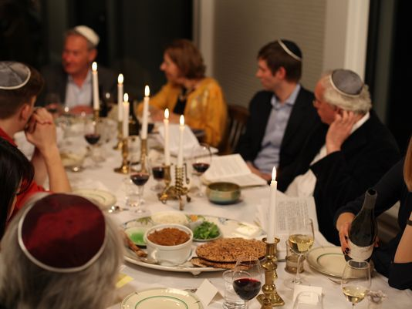

Passover, Pesach in Hebrew, is one of the most important Jewish holidays
The festival lasts for seven days between Nissan 15-22 in the Hebrew calendar
It has been celebrated every year in spring since around 1300 BC[E]
Passover is one of the most important Jewish holidays, celebrating the time when Moses led the Jewish people out of enslavement in Egypt to freedom.
The festival, Pesach in Hebrew, lasts seven days in Israel and for Reform Jews, however some congregations celebrate the holiday over eight days.
It has been celebrated every year in spring since around 1300 BC and involves rituals such as consumption of ceremonial foods and special prayers on Passover Seder nights.
Here’s all the information on Passover including what is it, when is Passover 2018 and why do Jews celebrate it.
When is Passover 2018?
Passover 2018 starts at sundown on March 30 and ends on April 7.
In the Hebrew calendar, the dates for Passover are Nissan 15-22.
The first night of Passover 2018 is March 30.
March 31/April 1 and April 6/7 are Yom Tovs. Yom Tovs translate as 'Good Days' and a time during which working is prohibited.
In 2017, Passover started on April 11 and ended on April 18.

What is Passover?
Passover is a Jewish holiday that celebrates the time when Moses led the Children of Israel from Egypt and enslavement. The story is set out in the Book of Exodus in the Old Testament.
The Book Exodus tells the story of how the Jews settled in Egypt when Jacob and his sons went there to be reunited with Joseph. As long as Joseph and his siblings were alive, the Jewish people were treated with respect in Egypt.
However, after Joseph died and a new Pharaoh came to the throne, the attitude changed. 'Behold the Children of Israel are more and mightier than we. Come, let us deal wisely with them; lest they multiply,' it says in Exodus 1:8-10.
The Jewish people became enslaved and the Pharaoh ordered for all newborn sons to be drowned in the Nile. One such newborn was Moses, who was saved from drowning when his mother placed him in a basket and set him down the river.
The baby is discovered by the Pharaoh’s daughter and names him Moses, which translates into English as ‘he who was drawn from the water’.
Moses grows up with the Pharaoh’s family but does not forget his true heritage. One day he sees an Egyptian slave driver beating a slave and kills him and flees Egypt to become a shepherd.
However, G-d intervenes and appears to Moses as a burning bush and tells him to go before the Pharaoh and demand that he ‘Let My people go, so that they may serve Me.’
The Pharaoh refuses and instead intensifies the Jewish people’s torment. Moses continues to return and demand freedom for the Children of Israel, each time the Pharaoh refuses, ignoring the warnings that G-d would smite Egypt with terrible plagues.

The Ten Plagues of Egypt
G-d turned the water of the River Nile into blood, causing all life in the river to die. Then all the water in Egypt turned to blood.
The second plague saw Egypt overrun with a swarm of frogs.
The Plague of Lice saw all dust turned into lice, which infected everyone.
In the fourth plague, all animals in Egypt died including horses, camels, sheep and goats.
A Plague of Flies fills every Egyptian house, including the Pharaoh’s palace.
The Egyptians are plagued by terrible boils.

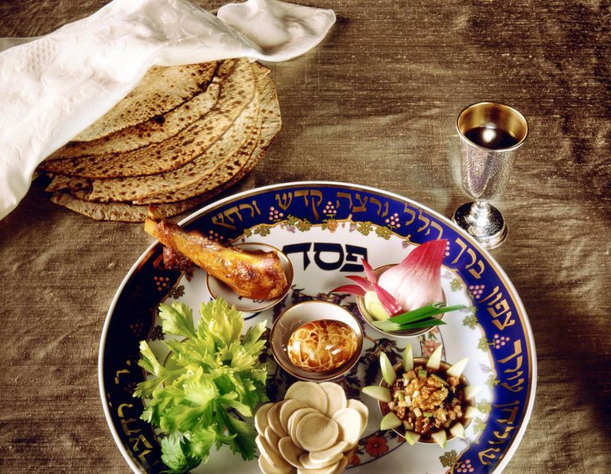

A Hail made up of fire and ice terrorises Egypt. The Pharaoh still refuses to free the Jewish people, ignoring the pleas of his people.
Anything that survived the hail, was then consumed by a Plague of Locusts.
Egypt descends into darkness for three days.
The tenth and final plague saw an avenging angel go to every Egyptian house and kill the first-born. On the stroke of midnight of Nissan 15, all of Egypt’s firstborn are killed.
To ensure the Children of Israel were passed over, i.e. weren’t touched by the angel, G-d ordered them to brush their door frames with the blood of a freshly slaughtered male lamb, then roast the lamb and consume it with bitter herbs and unleavened bread.
The Pharaoh gives in after the tenth plague and begs the Jewish people to leave. The Jews leave Egypt so quickly that they don’t have time to let the dough of the bread rise with yeast, meaning all their bread is unleavened.
However, the Pharaoh then changes his mind and pursues the Jews to force them to return. The Jewish people end up being trapped between the Pharaoh’s army and the Red Sea.
G-d orders Moses to raise his staff and suddenly the Red Sea parts down the middle, allowing the Jewish people to pass through.

Why do Jews celebrate Passover?
The Book of Exodus says how G-d ordered the Children of Israel to commemorate this period every year by removing all leaven and eating matzah instead.
'This day shall be for you a memorial day, and you shall keep it as a feast to the L-RD; throughout your generations, as a statute forever, you shall keep it as a feast,' it says in Exodus 12:14.
Passover meal, celebrations and traditions
The most famous part of Passover is the removal of Chametz (leaven) from the house. This means anything that is a ‘risen’ product of a combination of water and one of five types of grain (wheat, spelt, rye, barley and oat) are not allowed.
Fermented drinks such as beer and champagne are also not allowed.
On Passover Seder night, family and friends get together and follow a 15-step process that includes prayer, washing and eating foods in a specific order.
A passover Seder meal will usually consist of red wine, vegetables dipped in saltwater, matzah, bitter herbs such as horseradish and may feature matzo ball soup or gefilte fish.
Throughout the night, everyone takes part in reading passages from the Haggadah, which means ‘Narration’ and tells the story of how the Jewish people fled Egypt.
The part that kids probably look most forward to is the afikoman. On the Passover Seder table, under the Seder plate, there will be three matzahs.
The middle piece is taken and then split. The largest part of that piece is called the afikoman, from the Greek epikomen, which means 'that which comes after'. It is wrapped in cloth and eaten for dessert, a symbolic gesture to remember how quickly the Jews had to leave Egypt, when they wrapped their unleavened bread in their clothes.
The reason it may be the favourite part for children is because the afikoman is traditionally hidden in the house and the kids have to find it and bring it back to the table.

Reprinted from the February 20, 2018 website of the Daily Mail (United Kingdom)
Parshas Ki Sisa 5778 Volume 4 - Issue 18
Above and Beyond
Yom Tov in Space
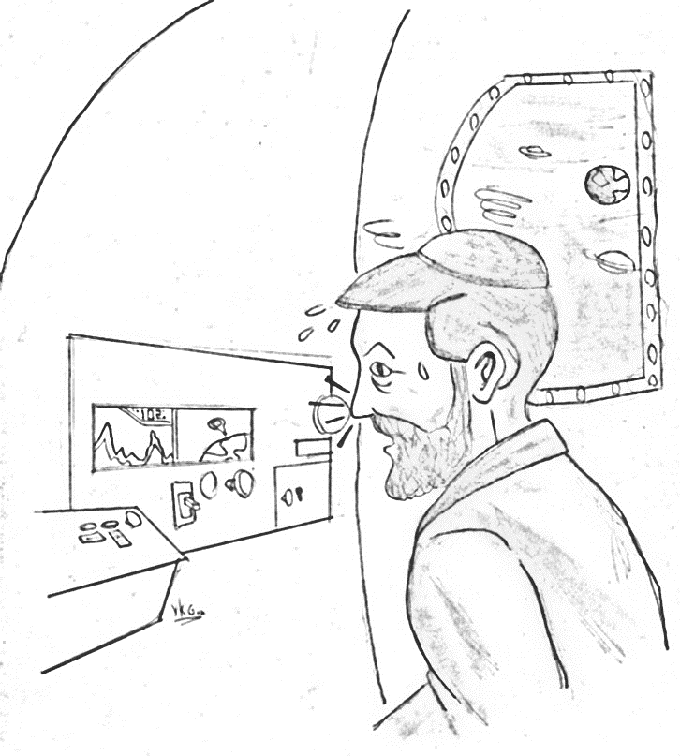
Sarah Zorgelbean called her father, Rabbi Berger, the day after Purim, “Tatty, Zelig and I are planning to go to Eretz Yisroel for Pesach. Can we fly there using your slingshot rocket launcher (see Excitement in Halacha: Becoming Younger)? We would save a lot of money.”
Rabbi Berger replied, “Sure Sarah, just come over to our house after bedikas chametz. We will pack all your clothing, matzos and the rest of your stuff for Pesach into the ship. You know our rocket goes outside the atmosphere to able to accelerate there, and that way you can get to Eretz Yisroel in a half hour. I will set the rocket on autopilot that it can fly to Eretz Yisroel by itself.”
A few weeks later, on the night before Pesach, the Zorgelbeans were on the way to Eretz Yisroel. While they were out of the atmosphere, Zelig noticed a large red button in the cockpit. He was looking at the inscription under it. Suddenly there was some turbulence and Zelig’s nose banged into the button.
Suddenly, the ship went speeding and whizzed past the moon.
Zelig exclaimed, “Sarah, what is going on! Aren’t we supposed to be in Eretz Yisroel already!”
Sarah responded, “It seems that the red button in the cockpit is the accelerator which makes the ship travel close to the speed of light (see Excitement in Halacha: Sukkos on Mars).”
Zelig responded, “I am trying to radio your father for help, but it will take at least a half an hour for the signal to reach him.”
Sarah asked, “In meanwhile, if we will be stuck out here for Pesach, how will we keep Yom Tov here in outer space?”

Zelig responded, “I learned that the rules of going to outer space could be derived from the laws of a person who went off course in the desert and lost track of time. He is obligated to designate the seventh day as Shabbos starting from when he realized that he confused the time. The Rabbanon instituted that he makes Kiddush and Havdalah to differentiate that day from the others to remember Shabbos. When one is in outer space there is no normal sunup and sundown as on Earth; therefore, there is no Torah obligation of time-dependent Mitzvos. One therefore calculates every 24 hours as another day. It seems that one would continue calculating time from where he left Earth. One would then designate the seventh 24-hour cycle as Shabbos.”
Points to Ponder
Sarah probed further, “You are only telling me the rules of Shabbos in space. Do we also designate the calendar day as Yom Tov, and make Kiddush and Havdalah too?”
Written by: Simcha Zisel Nakdimen  Edited by: Rabbi Benzion Weissberger  Illustrated by: Yosef Kadish Greenberg
Reviewed by: Rabbi Meir Platnick

r
Zelig replied, “The Gemara learns out the original rule of someone lost in the desert from the first Shabbos of creation. Therefore, it seems we only apply this rule regarding Shabbos and we would not designate a day for Yom Tov. Consequently, there wouldn’t be an obligation of Kiddush and Havdalah either.”
Sarah exclaimed, “Then we will lose out in keeping in all the mitzvos of Yom Tov!”
Conclusion
Suddenly, as they were flying past Mars the ship made a U-turn heading towards Earth. Rabbi Berger had received the message and was taking control of the ship to bring it back on course. The Zorgelbeans landed in Eretz Yisroel on time for Yom Tov.

או"ח שמד:א
קובץ אור ישראל מנסי תשרי שנה תשסג מתשובת רב שמואל שכטר; תשובות והנהגות חלק ה:פד
מור וקציעה המובא בשערי תשובה שמד:א; תאריך ישראל סמין ה:ה הארעה יד' ygutwein@gutweincpa.com
קובץ אור ישראל מנסי תשרי שנה תשסג מתשובת נטעי גבריאל שם; בצל החכמה חלק ד:קד; פסקי תשובות ג-א שמד:ה; עיין תשובות והנהגות חלק ה:פד
קובץ אור ישראל מנסי תשרי שנה תשסג מתשובת רב שמואל שכטר שם ותשובת נטעי גבריאל שם;
שבת סט:.

